Introduction

In our country many illegal and dummy voting occurs in voting system and many people are not able to vote because of poor identification. So to avoid this problem we implement high security for voting system using offline signature recognition and verification system.
In this project we create a database of signature data base of name an address of different persons for in for election process of voter registration, vote casting, vote counting and ballot generation automatic done features of samples of signature images match it with data base if match found of same threshold than display name, photo and signature of the person whose signed than the person are able for voting. If match is not found up to some threshold hence no sample found in the database in the signature sample is not authenticate and the person is unable for voting.
Some basic criteria also available for voting system
- Confidentiality
- Integrity
- Availability
- Reliability

Signature verification and Recognition technology utilizes realise the distinctive aspects of the signature to the signature verify the identity of individual. Signature of person is an important biometric attributes of human being and issued for authorization purpose for decodes a signature is a hand written depiction of some one names that writes in a documents. Hand writing signature have prove the identity of a person signing the documents so there is vast scope to develop fast algorithms for signature recognition there is a lot of research work is being carried out in this field various approach are possible for signature recognition with a lot of scope of research. Because of the signature verification & detection become crucial and hand written signature different largely in their shapes size and the variation are so much that it is very difficult for a human being to find.
In our project we have implemented a simple contour based signature recognition technique. Along with various parameters like number of pixels, angle of rotation, width, and height etc. We are using Ex-oring of the bands to find out variation in the signature pixels.
In this project we use a novel & simple technique based on signature template. This technique can be easily implemented in a programming language like visual basic 6.0 and MATLAB. Automatic signature recognition and verification system is categorized in two major classes
- On-line signature Recognition & verification
- Off – line signature Recognition & verification

The difference between online and offline is that the how data can obtain. In online signature recognition and verification have data are obtained using electronics pads, using electronic sensor etc. The signature recorded while the person is actually signing it. In offline signature Recognition & verification images of the signature written on a paper are obtained using scanners or camera. In this project we deal with of line signature Recognition & verification technique where the signature is capture and presented to the user in the format of image only in this project we have implemented an off line signature of verification so we can first scan the hand written signature and than undergo a series of image preprocessing technique. Means the signature are binary , in which the image is converted into black & white then remove noise from the picture to get a clear image for database we can take the sample uses signature and create database hand written signature different largely in their shapes and size and the variation are so much that it is difficult to find out a forged signature to locate it we can use a advance techniques in this project.
When the sample base data are created than the sample can scan image check for every signature we obtain the x and y and coordinates and the pressure exerted of the writing style also each signature was represented as a data set with x,y,pressure and different dependent variables on time.

We can use plotting in
X vs time plot
Y vs time plot
Pressure vs time plot
In this project different type of features can be extracted for signature like distance features angle features, contour measures etc. In our project angle features are use since they are found to better than other features distinguish the variation can be the signature a divided into 3 rows and 20 columns & for each block the average angle is calculated In our project mostly the signature are taken from the samples signed on the white sheet but where the background is not exactly white, then image is converted to black and white so can removed the noise the clear image given. In our project used the implementing the recognition process we have use a simple way for getting accuracy up nearly 70% to 80% this technique simple to apply in program coding and features performance can be improve by using better classification algorithm we use the concept recognition means finding the identification of the signature owner we say signature are faulty or dummy .
The faulty image can be classified in 3 groups
- Random
- Simple
- Skilled

Random fault are form without any knowledge of the signers names and signature shapes. Simple fault are formed without any knowledge of the signer name and signature shape.
Skill fault are formed knowing the name of the signer & know the exact shape of signature . This system also useable in banking sector, passport office, RTO office, Industrial sector for employed and many application where signature required. In our project we used real time signature verification so this method be occurs & quick.
Flowchart for Generation of Database

In this project we use the concept offline signature recognition for the security of voting system. Signature recognition means identification of the signature. Implementation of this system is classified into two phases.
1. Data base generation
2. Signature Recognition

1. DATA Base Generation
Fig. A shows the flow chart of data base generation. In high secured voting system we have to generate database in which signature, name, photo, address related to person is stored. For data base generation, we required sample of signature image, name, address, and photograph of a person. In our system, we take ten such sample of signature for a person.
Above flowchart describes the process of generation of database. For the generation of database first we scan signature. Take the sample of scanned signature. Signature scan in grayscale. To make the signature standard this signature is processed through five steps.
- Background elimination
- Color effect normalization
- Size normalization
- Width normalization
- Thinning
This standard signature is used to extract the feature like global feature ,mask feature, gird feature. This feature extracted from the signature is stored in learning module with image, name, address, and photograph related to particular person which is commonly called as data base.
Flowchart
Take image sample of signature
Normalize it to get binary image
Extract the feature
Create data base from extracted features
Store data base of one person signature with his photography
Start
Stop

Flowchart for Signature Recognition :
Start
Take a sample of signature which to be recognized
Normalize it
Signature extracts the feature of sample image
Match it with data base
Is match found up to some threshold
No sample found in database signature sample is not authenticate
Display name , photo and signature of person whose signature is taken as sample
Stop

no

yes

2. Signature Recognition
Fig. B shows the flow chart of signature verification. In the process of signature verification first we scan the signature which is to be recognized or verified. this scan signature is converted into standard form by using the processes like
- Background elimination
- Color effect normalization
- Size normalization
- Width normalization
- Thinning
This standard signature is used to extract the feature like global feature, local feature, grid feature, mask feature. In the classification module compare this extracted feature with extracted feature stored in the data base. if the matched is not found ,the system displays the signature is not authenticate. If the match is found, the signature is authenticate and the system displays name , photograph ,address of the person related to the signature.

Signature recognition….

Signature recognition is the process of signature identification .The signature recognition is the process of verifying the writer's identity by checking the signature against samples kept in a database. The result of this process is usually a number between 0 and 1 which represents a fit ratio (1 for match and 0 for mismatch). The threshold used for confirmation/rejection decision depends on the nature of the application
Many times the signatures are not even readable by human beings. Therefore a signature is treated as an image carrying a certain pattern of pixels that pertains to a specific individual. Signature Verification Problem therefore is concerned with determining whether a particular signature truly belongs to a person or not.
Signatures are a special case of handwriting in which special characters and flourishes are viable. Signature Verification is a difficult pattern recognition problem as because no two genuine signatures of a person are precisely the same. Its difficulty also stems from the fact that skilled forgeries follow the genuine pattern unlike fingerprints or irises where fingerprints or irises from two different persons vary widely. Ideally interpersonal variations should be much more than the intrapersonal variations. Therefore it is very important to identify and extract those features which minimize
A signature verification system has five components:
- Data capture -- the process of converting the signature into digital form.
- Preprocessing -- the data transformation in a standard format.
- Feature extraction -- the process of extracting key information from the digital representation of the signature.
- Comparison process -- matches extracted features with templates stored in a database. Usually, the output is a fit ratio.
- Performance evaluation -- the decision step typically made

- Principal structure of signature recognition system
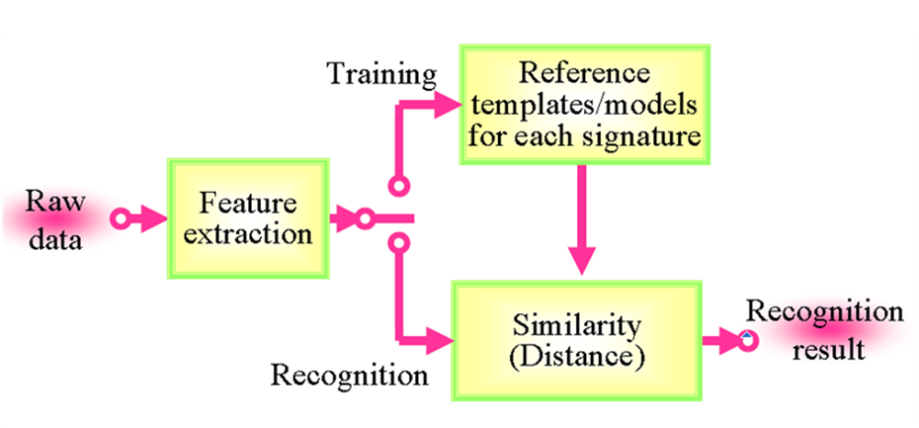

The system we introduced is divided into two major parts:
    - Training signatures, (ii) Verification or recognition of given signature.
    - The block diagram of the system is given in Fig-ure 1

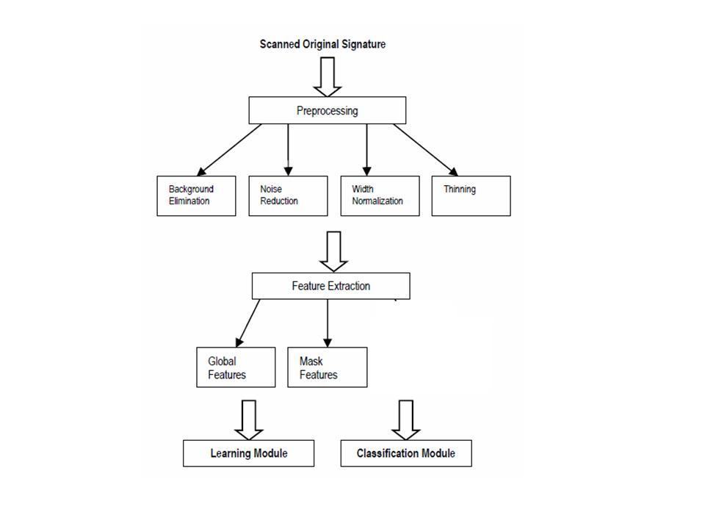
Grid
Feature

Fig. Block diagram of proposed system

- PREPROCESSING

The preprocessing step is applied both in training and testing phases. Signatures are scanned in gray. The purpose in this phase is to make signatures

standard and ready for feature extraction. The preprocessing stage includes four steps: Background elimination, noise reduction, width normaliza-tion and skeletonization. The preprocessing steps of an ex-ample signature are shown in Fig. 2.

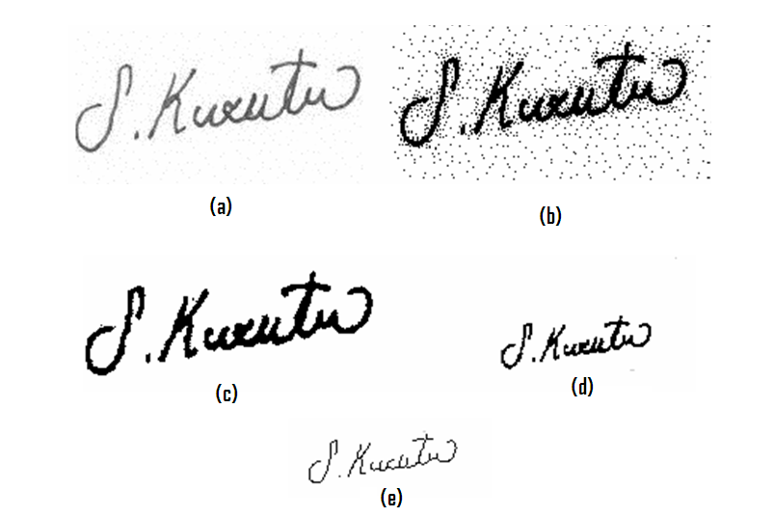
Fig . Preprocessing steps: (a) scanning, (b) background elimination, (c) noise reduction, (d) width normalization, (e) thinning applied signatures
- Background Elimination

Data area cropping must be done for extracting features. P-tile thresholding was chosen to capture signature from the background. After the thresholding the pixels of the signature would be “1” and the other pixels which belong to the back-ground would be “0”.

- Noise Reduction

A noise reduction filter is applied to the binary image for eliminating single black pixels on white background. 8-neighbors of a chosen pixel are examined. If the number of black pixels is greater than number of white pixels, the cho-sen pixel will be black otherwise it will be white.

- Width Normalization

Signature dimensions may have intrapersonal and interper-sonal differences. So the image width is adjusted to a default value and the height will change without any change on height-to-width ratio. At the end of width normalization width dimension is adjusted to 100.

- Thinning

The goal of thinning is to eliminate the thickness differences of pen by making the image one pixel thick. In this system Hilditch's Algorithm is used.

FEATURE EXTRACTION

Extracted features in this phase are the inputs of training phase. The features in this system are global features, mask features and grid features. Global features provide informa-tion about specific cases of the signature shape. Mask fea-tures provide information about directions of the lines of the signatures. Grid features provide overall signature appear-ance information. The feature extraction steps of an example signature are shown in Fig. 3.
Variety of feature can be used:
- Angle of the pen,
- Pressure of the pen,
- Total signing time,
- Velocity and acceleration,
- Geometry.

- Global Features

Signature area is the number of pixels which belong to the signature. This feature provides information about the signa-ture density. Signature height-to-width ratio is obtained by dividing signa-ture height to signature width. Signature height and width can change. Height-to-width ratios of one person’s signatures are approximately equal.
Maximum horizontal histogram and maximum vertical his-togram: The horizontal histograms are calculated for each row and the row which has the highest value is taken as maximum horizontal histogram. The vertical histograms are calculated for each column and the column which has the highest value is taken as maximum vertical histogram. Horizontal and vertical center of the signature are calculated using the formulas in Eq.

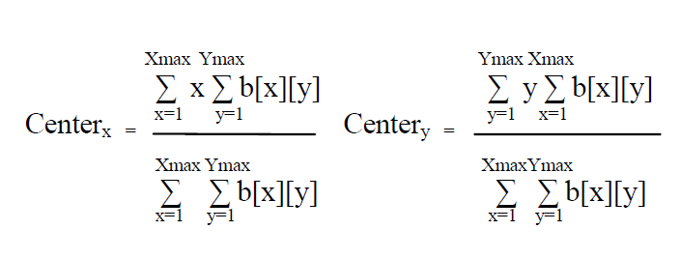

Local maxima numbers of the signature: The number of local maxima of the vertical and horizontal histogram is calcu-lated.
Edge point numbers of the signature: Edge point is the pixel which has only one neighbour, which belongs to the signa-ture, in 8-neighbor.

Fig. Feature extraction steps: (a) preprocessed signa-ture and (b) height, (c) maximum vertical histogram, (d) maximum horizontal histogram, (e) horizontal center, (f) vertical center, (g) horizontal local maxima numbers, (h) vertical local maxima numbers, (i) edge points, (h) grid features of the signature.

- Global features
  - Signature length, height, weight
  - Total signature time
  - Total pen-down time
  - Total pen-up time
  - Average velocity
  - Maximum velocity
  - Minimum velocity
  - –etc,.

- Local features
  - x, y coordinates
  - Velocity (v)
  - Acceleration (A)
  - Trajectory angle (Θ)
  - Azimuth
  - Elevation
  - First derivative of feature (Δ)
  - Second derivative of feature

    - Mask Features
Mask features provide information about directions of the lines of the signatures. The angles of the signatures have in-terpersonal differences. In this system 8 different 3x3 mask features are used. Each mask is taken all around the signa-tures and the number of 3x3 parts of the signature, which are same with the mask, is calculated.

- Grid Features
Grid features are used for finding densities of signature parts [10]. In this system 60 grid features are used. Signature is divided into 60 equal parts and the image area in each divided part is calculated.

SIGNATURE DATABASE

For training and testing of the signature recognition and veri-fication system 1320 signatures are used. The signatures were taken from 70 persons. For training the system 40 persons’ signatures are used. Each of these persons signed 8 original signatures; other 30 per-sons imitated the signatures. For each person 4 forgery signa-tures are signed. In the training set the total number of signa-tures is 480 (12 x 40).
In order to make the system robust, signers were asked to use as much as variation in their signature size and shape and the signatures are collected at different times without seeing other signatures they signed before. For testing the system, another 320 genuine signatures and 320 forgery signatures are taken from the same 40 persons in the training set.
Signature verification
In the process of signature verification first we scan the signature which is to be recognised or verified. this scan signature is converted into standerd form by using the processes like
- Background elimination
- Color effect normalization
- Size normalization
- Width normalization
- Thinning
This standard signature is used to extract the feature like global feature, local feature, grid feature, mask feature. In the classification module compare this extracted feature with extracted feature stored in the data base.if the matched is not found ,the system displays the signature is not authenticate. If the match is found, the signature is authenticate and the system displays name , photograph ,address of the person related to the signature.

Advantages & Disadvantages

Advantages

- Resistance to forgery
- Widely accepted
- Non-intrusive
- No record of the signature
- User-friendly.
- Well accepted socially and legally.
- Non invasive.
- Already acquired in a number of applications.
- Acquisition hardware
- Off-line: ubiquitous (pen and paper).
- On-line: inexpensive and already integrated in some devices (Tablet PC).
- If compromised, can be changed.
- Long experience in forensic environments.
- Signature is a man-made biometric where forgery has been studied extensively
- Enrollment (training) is intuitive and fast
- Signature verification in general has a fast response and low storage requirements
- A signature verification is “independent” of the native language user
- Very high compression rates do not affect shape of the signature (100-150 bytes)

Disadvantages
- Signature inconsistencies
- Large templates (1K to 3K)
- Problem with trivial signatures
- High user intra-variability.
- Higher error rates than other traits.
- Affected by the physical and emotional state of the user.

Benefits of secure voting system using signature recognition

- it Modernizes the election process.
- it User friendly.
- It is Simple to operate and it can be installed in a short time
- it Preserves voting secrecy
- it has No scope for invalid votes
- it Facilitates quick and accurate counting – possible to declare results instantaneously
- Huge expenditure involved in printing, storing and transportation and security of ballot paper can be avoided
- Lowers operating costs
- Easier to manage with less demand on man-power

- Many times we observe that one person can easily copy the signature of other person. our system dipslays the photograph of a person which is stored in databased during the survey. From the face reading the system user can identify the doughtfull person and not allowed for voting .this the biggest advantage of this system
- More likely to be used by voters : Most people are online at some point during the day, and would be more inclined to complete a simple, three-minute online form than pick up a pen, manually complete the questions, put the form in an envelope and take it to the post box.

Better for business :Castavote can considerably reduce the manpower and facilities needed to handle an election so provides cost and time savings across the board. It also promotes a modern image for any organisation, association, club or business.

Conscious about Security : Online security is incredibly high on everyone’s list of concerns these days which is why we have made it possible to integrate Castavote into your own website. This means that when using the system, voters won’t get the impression they are being re-directed away from your website to another location where they feel their safety is being jeopardised.

Castavote offers exceedingly high levels of security. All voting data is secured by 128-bit SSL security certificates on servers that are protected by several of the very best hacker, fraud and malicious code safeguards.

Versatile : Castavote can be used by a range of industries for any type of election, ballot or public vote and can be tailored to suit any specific requirements, corporate colours and designs.

FUTURE EXPANSIONS

This Techniques can be used :
- In a banking sector
- R.T.O. Office
- Passport Office
- Industrial sector
- College and Schools
Conclusion

We proposed and presented a new offline signature verification and recognition techniques which is based on global mask, grid features of signature and signature verification method and we can secure voting system using Signature Recognition by providing image.

References
Books :
- Digital Image processing with Matlab - Wood & Gonzaleth
- Software design - Ajay Mitra
- Signature Verification : Increasing
performance by a Multi-stage System” - Sansone & Vento

Websites :
- www.matwork.com
- www.wikipedia.com

